Using UCF System Variables
Richard Todd
Test Engineering Services
03.15.2023

Description
System variables provide an alternative to hard-coded system configuration values.
The following types of variables are supported

Global variables that are common to all profiles

Local variables that are common to a specific profile group
Local variables will always override global variables of the same name.

Data Locations
System variables are stored in local or global sqlite databases and are configured using the ‘DB Browser for Sqlite’ application.

Locations
Database Type | Database Location | Platform
Local | ~/ucfroot/opt/<Profile Family Name>/ExtSystemIO.sdb | Linux
 | C:\ucfroot\opt\<Profile Family Name>\ExtSystemIO.sdb | Windows
Global | ~/ucfroot/bin/<Release Name>/IOConfig/BaseSystemIO.sdb | Linux
 | C:\ucfroot\bin\<Release Name>\IOConfig\BaseSystemIO.sdb | Windows

Local database values are unique to a specific profile family and will override values in global databases.

Global database values will be used for all profiles that do not have overriding values in a local database.

Configuring System Variables
System variables are created and updated using the sqlitebrowser utility.
  - Available at: https://sqlitebrowser.org/
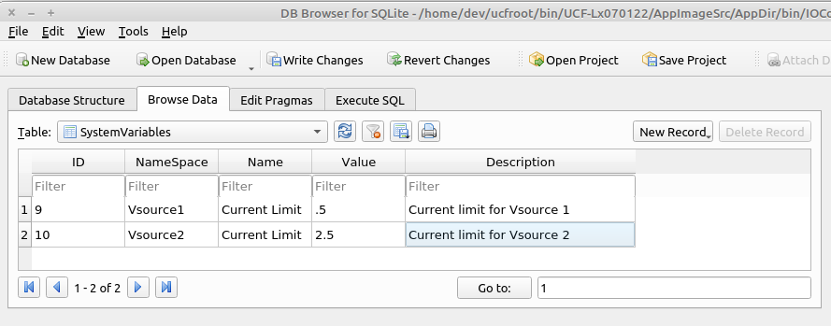

Reading System Variables
The value(s) for system variables are read programmatically using the ‘GetSystemVariable(...)’ functions defined in iStdIOChannelSystem.hpp.
Example 1:
bool status=TheSystem->GetSystemVariable(..);
/* TheSystem is an iStdIOChannelSystem*
1. status will be true if the variable is found, and false if not
*/

Example 2:

int TplModule::TestSystemVariables(CmdParam msg) {
std::string ns, name, value, desc;
char cvalue[256];
memset(cvalue,0,256);

TokenString params(msg,',');
if (params.GetTokenCount() > 3) {
params.GetToken(1, ns);
params.GetToken(2, name);
params.GetToken(3, value);
params.GetToken(4, desc);
TheSystem->GetSystemVariable(ns.c_str(), name.c_str(),cvalue,256);
}
return(1);
}

TokenString Methods
The following TokenString methods are useful for reading multi-type system variables with default values.
std::string GetStrToken(unsigned index,std::string default_value="");
IOString GetIOStrToken(unsigned index,std::string default_value="");
bool GetToken(unsigned index,std::string &value, std::string default_value="");
bool GetToken(unsigned index,unsigned &value,unsigned default_value=std::numeric_limits<unsigned>::min());
bool GetToken(unsigned index,int &value,int default_value=std::numeric_limits<int>::min());
bool GetToken(unsigned index,bool &value,bool default_value=false);
bool GetToken(unsigned index,double &value,double default_value=std::numeric_limits<double>::min());
/* get the specified token, and return the value as an std::string using 'default_value'
if the token is not found
*/

